**DAILY ONLINE ACTIVITIES SUMMARY**

|  |  |  |  |  |  |  |  |
| --- | --- | --- | --- | --- | --- | --- | --- |
| **Date:** | **20/05/20** | | | | **Name:** | **JYOTHI LAKSHMI** | |
| **Sem & Sec** | **8th sem, B sec** | | | | **USN:** | **4AL16CS129** | |
| **Online Test Summary** | | | | | | | |
| **Subject** | | **IoT** | | | | | |
| **Max. Marks** | | **30** | | **Score** | | **16** | |
| **Certification Course Summary** | | | | | | | |
| **Course** | **Introduction to Ethical Hacking** | | | | | | |
| **Certificate Provider** | | | **Great Learning** | **Duration** | | | **30 mins** |
| **Coding Challenges** | | | | | | | |
| **Problem Statement: 1) Generating Armstrong numbers using python 2) To reverse linked list in groups 3) Python prog to exchange the Values of Two Numbers using ^ operator** | | | | | | | |
| **Status: Completed** | | | | | | | |
| **Uploaded the report in Github** | | | | **Yes** | | | |
| **If yes Repository name** | | | |  | | | |
| **Uploaded the report in slack** | | | | **Yes** | | | |

Online Test Details:



The test was on the subject Internet of Things on Module 1 and Module 2.

Certification Course Details:

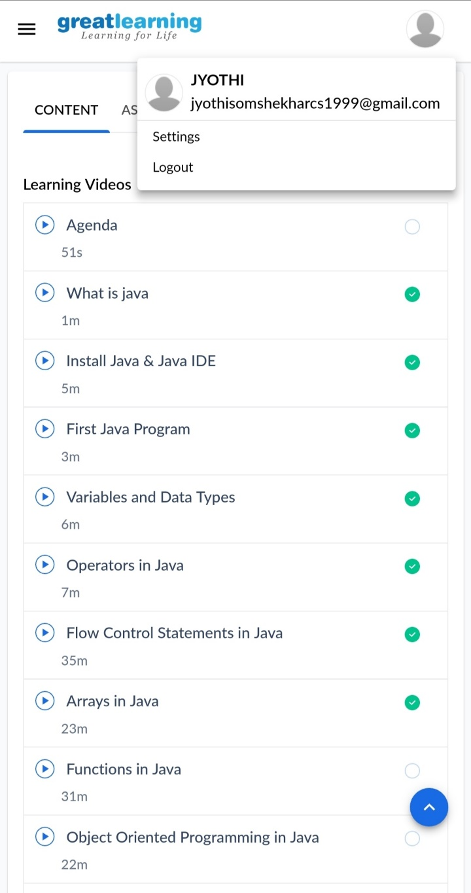

Coding Challenges Details:

1) Generating Armstrong numbers using Python programming language.

num = int(input("Enter a number: "))

sum = 0

temp = num

while temp > 0:

digit = temp % 10

sum += digit ** 3

temp //= 10

if num == sum:

print(num,"is an Armstrong number")

else:

print(num,"is not an Armstrong number")

2) Write a C Program to Reverse a Linked List in groups of given size.

Test Case 1:

If a linked listis: 1 → 2 → 3 → 4 → 5 → 6 → 7 → 8

The value of size k is 2

Then the linked list looks like: 2 → 1 → 4 → 3 → 6 → 5 → 8 → 7

Test Case 2:

If a linked listis: 1 → 2 → 3 → 4 → 5 → 6 → 7 → 8

The value of size k is 3

Then the linked list looks like: 3 → 2 → 1 → 6 → 5 → 4 → 8 → 7

struct Node

{

int data;

struct Node* next;

};

pointer to the new head node. /

struct Node reverse (struct Node head, int k)

{

struct Node current = head;

struct Node next = NULL;

struct Node prev = NULL;

int count = 0;

while (current != NULL && count < k) { next = current->next; current->next = prev; prev = current; current = next; count++; } if (next != NULL) head->next = reverse(next, k); return prev;

}

void push(struct Node** head_ref, int new_data)

{

struct Node* new_node =

(struct Node*) malloc(sizeof(struct Node));

new_node->data = new_data; new_node->next = (*head_ref); (*head_ref) = new_node;

}

void printList(struct Node *node)

{

while (node != NULL)

{

printf("%d ", node->data);

node = node->next;

}

}

int main(void)

{

struct Node* head = NULL;

push(&head, 8);

push(&head, 7);

push(&head, 6);

push(&head, 5);

push(&head, 4);

push(&head, 3);

push(&head, 2);

push(&head, 1);

printf("\nGiven linked list \n"); printList(head); head = reverse(head, 2); printf("\nReversed Linked list \n"); printList(head); return(0);

}

3) Python program Exchange the Values of Two Numbers using ^ operator

x=10 y=18 x = x ^ y; y = x ^ y; x = x ^ y; print ("After Swapping: x = ", x, " y =", y)